Contents

1 Sample T Test 1

Problem Statement: 1

Assumptions: 1

Sample Code: 1

6 Step Process: 1

2 Sample T Test 3

Assumptions: 3

## 1 Sample T Test

### Problem Statement:

Test the claim that the mean writing score is significantly different from 50.

### Assumptions:

1. Samples are drawn from a **normally** distributed population.
   1. If normal, move on if not
      1. Transform data or
      2. Central Limit Theorem if N>30 assume
      3. Sign Test or Wilcoxon Signed Rank Test
2. The observations in the sample are independent of one another.

### Sample Code:

proc ttest data = WORK.hsb2 alpha= .05 h0=50 sides=2;

var write;

run;

### 6 Step Process:

Step 1: Hypothesis

Ho = 50, Ha <> 50

#### Step 2: Critical Value

1.97

data quantile;

myquant = quantile('t',.975, 199); /*199 is N - 1 for ttest AND .05 FOR TWO TAIL */

run;

#### Step 3: Test Statistic

4.14

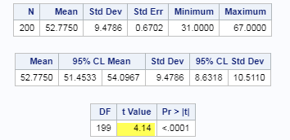

Code:

proc ttest data = WORK.hsb2 alpha= .05 h0=50 sides=2;

var write;

run;

Step 4: P-value

<.0001

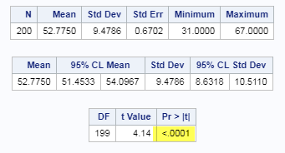

#### Step 5:

Reject the null

#### Step 6:

There is strong evidence to suggest at the alpha = .05 level of significance (p-value <.0001) that the mean writing score is different than 50 points. A 95% confidence interval for the true mean writing score is (51.5 points, 54.1points).

#### Scope of Inference:

We can infer that the mean is not equal to 50 for the entire population of interest as the data was a random sample.

## 

## 2 Sample T Test

### Assumptions:

1. Samples are drawn from a **normally** distributed population.
2. If it is a two sample test, both populations are assumed to have the same standard deviation (same shape).
3. The observations in the sample are independent of one another.